**PIZZA SALES SQL QUERIES**

Key performance indicators are quantifiable measures of performance over time for specific strategic objectives. Modern KPI dashboards allow any user to easily explore the data behind the KPIs and uncover actionable insights.

**A. KPI’s**

**1. Total Revenue:**

SELECT SUM(total_price) AS Total_Revenue FROM pizza_sales;

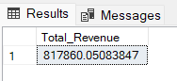

**2. Average Order Value**

SELECT (SUM(total_price) / COUNT(DISTINCT order_id)) AS Avg_order_Value FROM pizza_sales

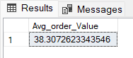

**3. Total Pizzas Sold**

SELECT SUM(quantity) AS Total_pizza_sold FROM pizza_sales

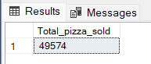

**4. Total Orders**

SELECT COUNT(DISTINCT order_id) AS Total_Orders FROM pizza_sales

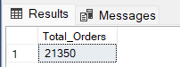

**5. Average Pizzas Per Order**

SELECT CAST(CAST(SUM(quantity) AS DECIMAL(10,2)) /

CAST(COUNT(DISTINCT order_id) AS DECIMAL(10,2)) AS DECIMAL(10,2))

AS Avg_Pizzas_per_order

FROM pizza_sales

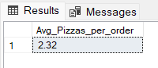

**B. Daily Trend for Total Orders**SELECT DATENAME(DW, order_date) AS order_day, COUNT(DISTINCT order_id) AS total_orders

FROM pizza_sales

GROUP BY DATENAME(DW, order_date)

***Output:***

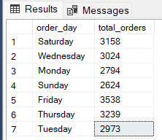

**C. Monthly Trend for Orders**

select DATENAME(MONTH, order_date) as Month_Name, COUNT(DISTINCT order_id) as Total_Orders

from pizza_sales

GROUP BY DATENAME(MONTH, order_date)

***Output***

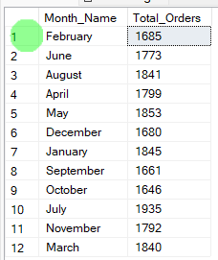

**D. % of Sales by Pizza Category**

SELECT pizza_category, CAST(SUM(total_price) AS DECIMAL(10,2)) as total_revenue,

CAST(SUM(total_price) * 100 / (SELECT SUM(total_price) from pizza_sales) AS DECIMAL(10,2)) AS PCT

FROM pizza_sales

GROUP BY pizza_category

***Output***

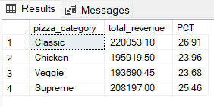

**E. % of Sales by Pizza Size**

SELECT pizza_size, CAST(SUM(total_price) AS DECIMAL(10,2)) as total_revenue,

CAST(SUM(total_price) * 100 / (SELECT SUM(total_price) from pizza_sales) AS DECIMAL(10,2)) AS PCT

FROM pizza_sales

GROUP BY pizza_size

ORDER BY pizza_size

***Output***

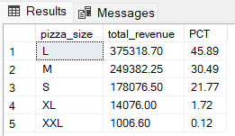

**F. Total Pizzas Sold by Pizza Category**

SELECT pizza_category, SUM(quantity) as Total_Quantity_Sold

FROM pizza_sales

WHERE MONTH(order_date) = 2

GROUP BY pizza_category

ORDER BY Total_Quantity_Sold DESC

***Output***

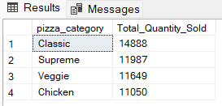

**G. Top 5 Pizzas by Revenue**

SELECT Top 5 pizza_name, SUM(total_price) AS Total_Revenue

FROM pizza_sales

GROUP BY pizza_name

ORDER BY Total_Revenue DESC

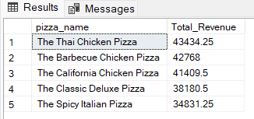

**H. Bottom 5 Pizzas by Revenue**

SELECT Top 5 pizza_name, SUM(total_price) AS Total_Revenue

FROM pizza_sales

GROUP BY pizza_name

ORDER BY Total_Revenue ASC

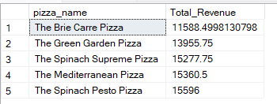

**I. Top 5 Pizzas by Quantity**

SELECT Top 5 pizza_name, SUM(quantity) AS Total_Pizza_Sold

FROM pizza_sales

GROUP BY pizza_name

ORDER BY Total_Pizza_Sold DESC

***Output***

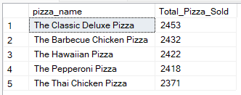

**J. Bottom 5 Pizzas by Quantity**

SELECT TOP 5 pizza_name, SUM(quantity) AS Total_Pizza_Sold

FROM pizza_sales

GROUP BY pizza_name

ORDER BY Total_Pizza_Sold ASC

***Output***

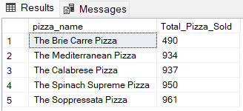

**K. Top 5 Pizzas by Total Orders**

SELECT Top 5 pizza_name, COUNT(DISTINCT order_id) AS Total_Orders

FROM pizza_sales

GROUP BY pizza_name

ORDER BY Total_Orders DESC

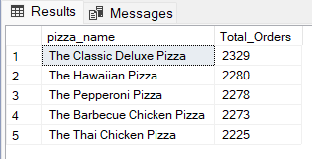

**L. Borrom 5 Pizzas by Total Orders**

SELECT Top 5 pizza_name, COUNT(DISTINCT order_id) AS Total_Orders

FROM pizza_sales

GROUP BY pizza_name

ORDER BY Total_Orders ASC

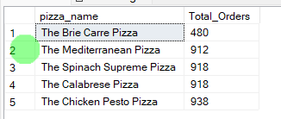

***NOTE***

If you want to apply the pizza_category or pizza_size filters to the above queries you can use WHERE clause. Follow some of below examples

SELECT Top 5 pizza_name, COUNT(DISTINCT order_id) AS Total_Orders

FROM pizza_sales

WHERE pizza_category = 'Classic'

GROUP BY pizza_name

ORDER BY Total_Orders ASC